

Azure Migrate Setup

In Progress

10th Magnitude, LLC
20 North Wacker Drive #530
Chicago, IL 60606

Notice of Confidentiality© 2018 10th Magnitude, LLC All rights reserved

THIS DOCUMENT IS 10TH MAGNITUDE PROPRIETARY AND CONFIDENTIAL INFORMATION AND IS SUBJECT TO THE TERMS OF THE 10TH MAGNITUDE NON-DISCLOSURE AGREEMENT. NEITHER THIS DOCUMENT NOR ITS CONTENTS MAY BE REVEALED OR DISCLOSED TO UNAUTHORIZED PERSONS OR SENT OUTSIDE THE AFOREMENTIONED COMPANY WITHOUT PRIOR PERMISSION FROM 10TH MAGNITUDE.Page Break
TABLE OF CONTENTS
Summary 2
Prerequisities3
Deployment 4
VMware 5
Hyper-V 6

Summary
This document is intended to describe Azure Migrate architecture and deployment in the (Clients Name) VMWare environment to support migration to Azure. Azure Migrate is a tool used to perform discovery, assessment and migration of on-premises infrastructure and applications. It even allows for the discovery of integrated tools developed by (ISVs).

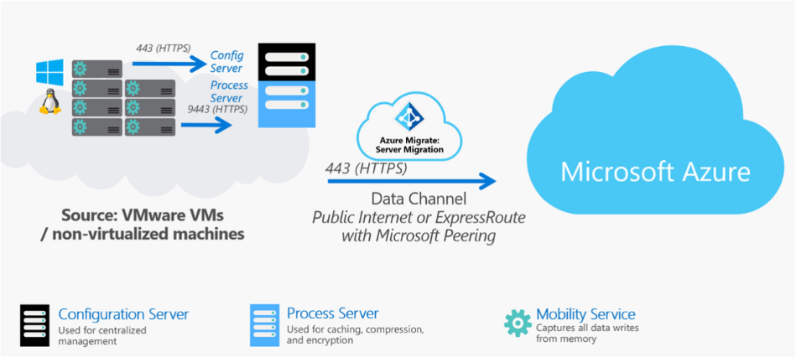

￼
Page Break
PREREQUISITIES

Azure Permissions
Create read-only account for vCenter Server
Azure migrate appliance requirements
Network connectivity/ports
Things to download

Page Break
Setup azure migrate: server assessment

Create your Migration project
- Log in to your Azure subscription; On the homepage, type Azure Migrate into the search bar

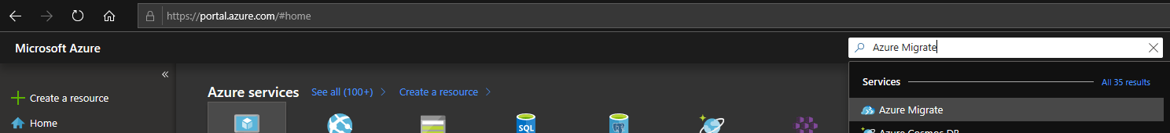

- On the Overview tab of the Azure Migrate blade click on the Assess and migrate servers button

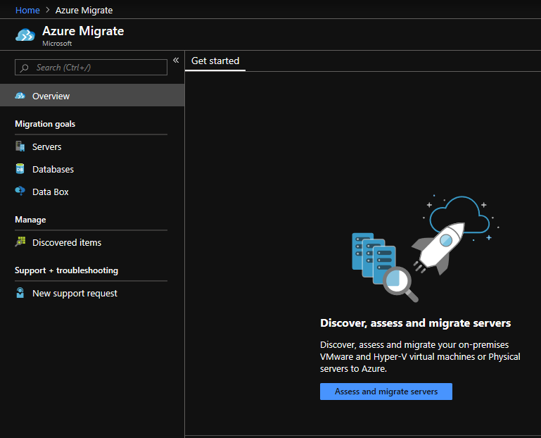
- This will bring you to the Servers tab; Click the Add Tool(s) button to create your migration project and add the (ISV) tools
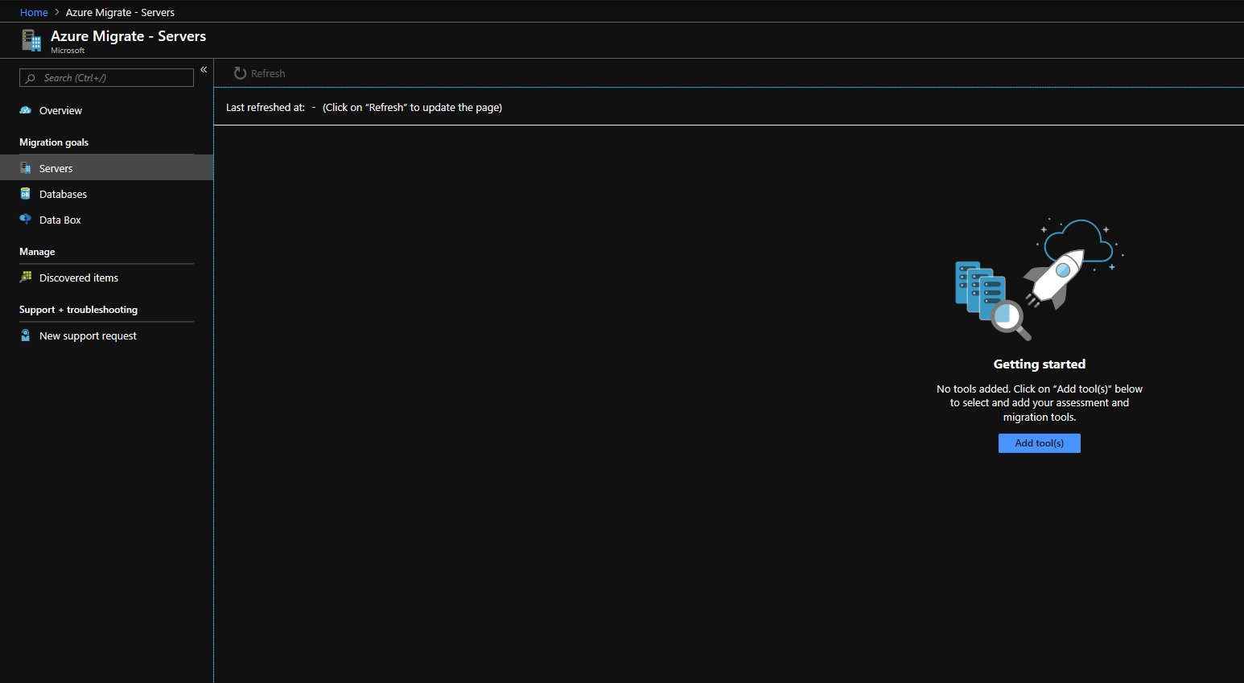

- Select your target Subscription, create or select a Resource Group, name your Migrate Project and select the geography you are in or closest to. Click Next

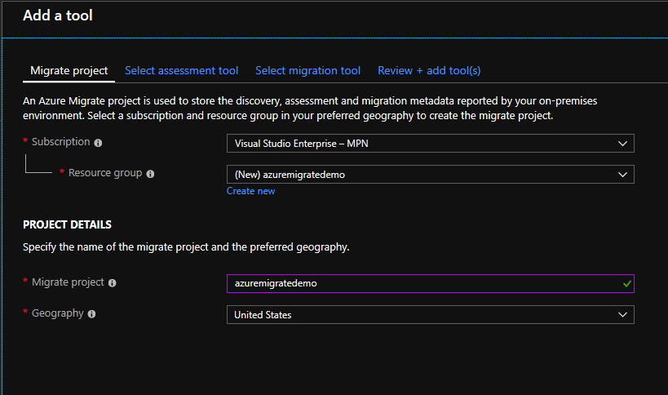

- Select a tool for server discovery and assessment. Click Next
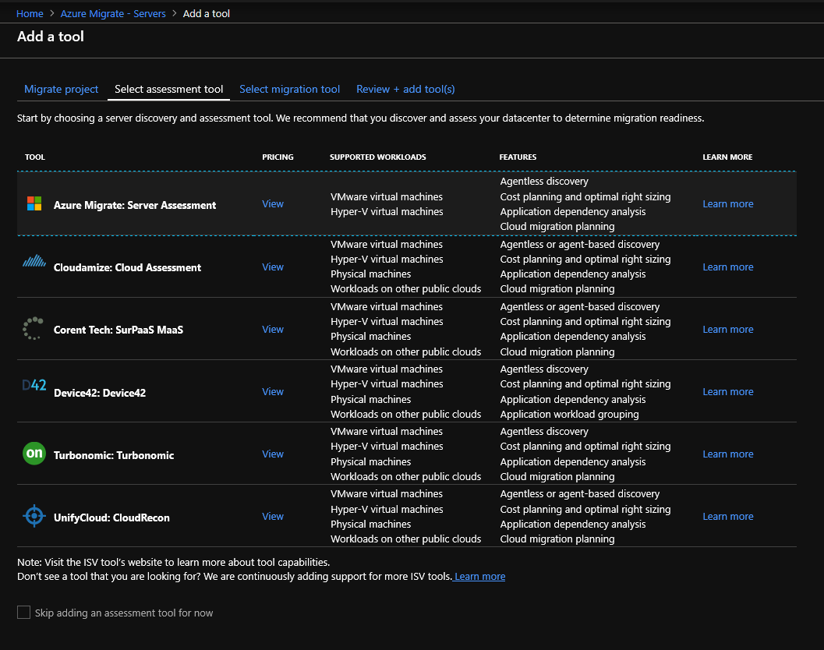

- Skip selecting a migration tool by checking the Skip adding a migration tool for now box. Click Next
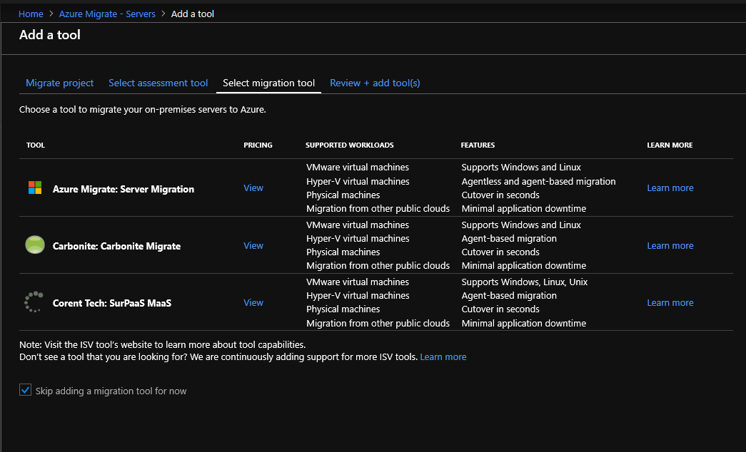
- Review the settings you have chosen for your migrate project and click Add Tool(s). The deployment will only take a few moments.
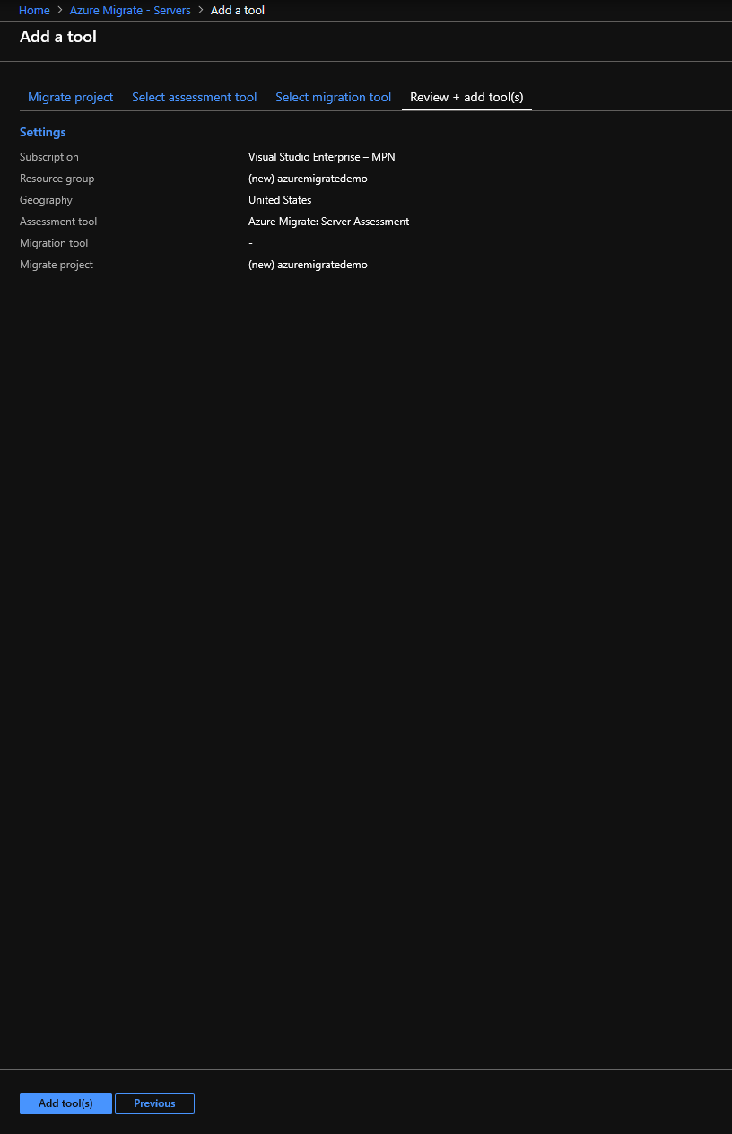

- Click on Servers under Migration goals on the Azure Migrate page to view the assessment tool you selected in your Migrate project. Click on Discover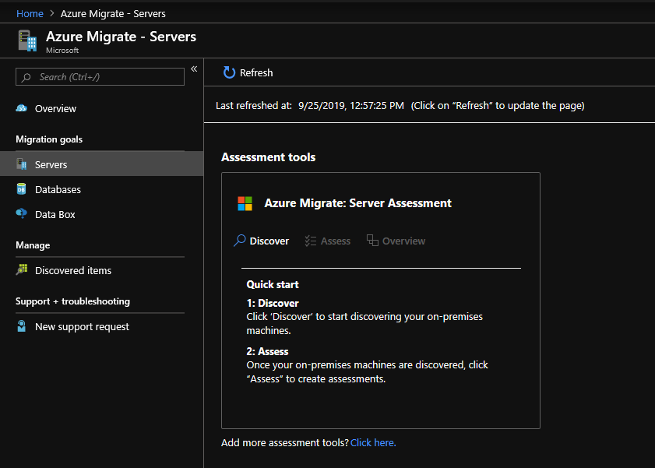
- In the Discover machines blade under Are your machines virtualized? Select Yes, with VMware vSphere Hypervisor
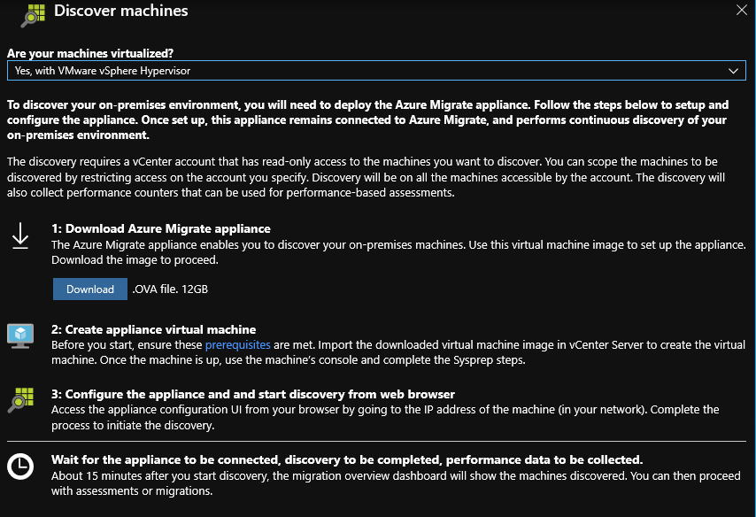
Step 10
- Click Download on the .OVA and click Save As to save to a safe location
- Verify you have the correct and most up-to date version by running the follow command in command prompt:
C:\>CertUtil -Hashfile <file location> [Hashing Algorithm]
Example: C:\>CertUtil -Hashfile C:\AzMigrateDemo\MicrosoftAzureMigration.OVA SHA256
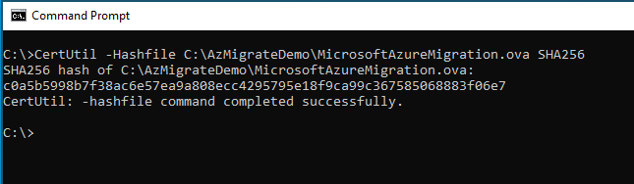

You can find the most updated hash settings on docs.microsoft.com

Deploy Azure Migrate Appliance VM on-premise

- In your vSphere Client, right-click Your Datacenter name and click Deploy OVF Template
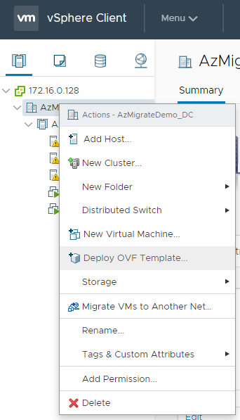
- In the Deploy OVF Template window > 1 Select an OVF Template select the Local File radio button and click on Choose Files
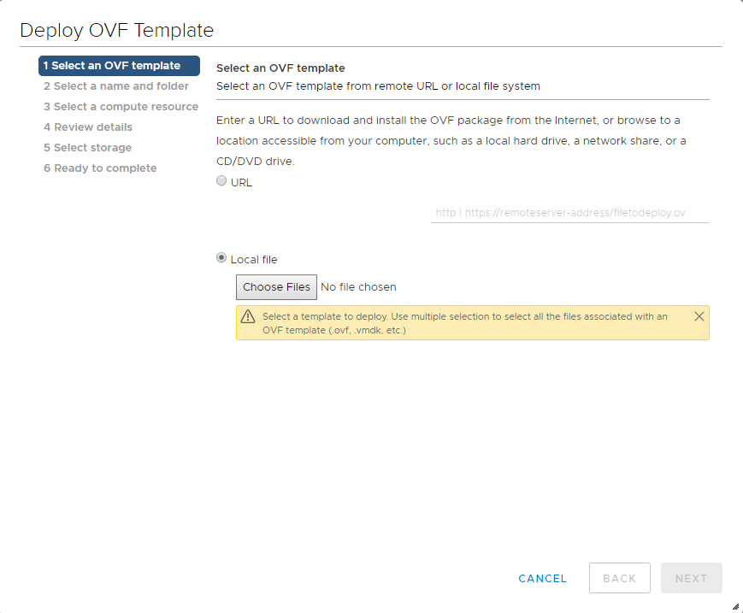
- Navigate to the location where you saved the .OVA file, select it and click Open – Click Next when File Explorer closes and you are back on the Deploy OVF Template page
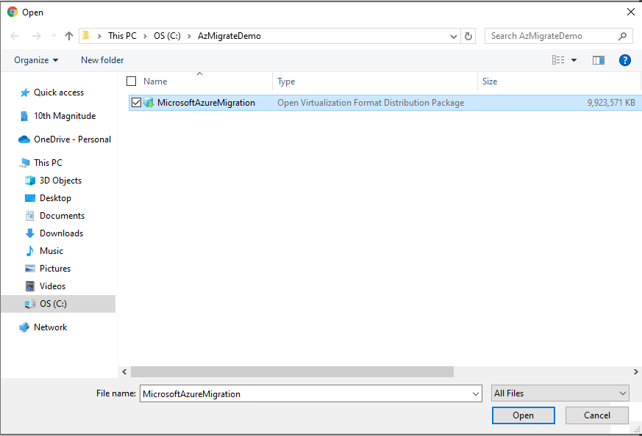

- In the Deploy OVF Template window > 2 Select a name and folder, name your virtual machine and select the location for the virtual machine – Click Next
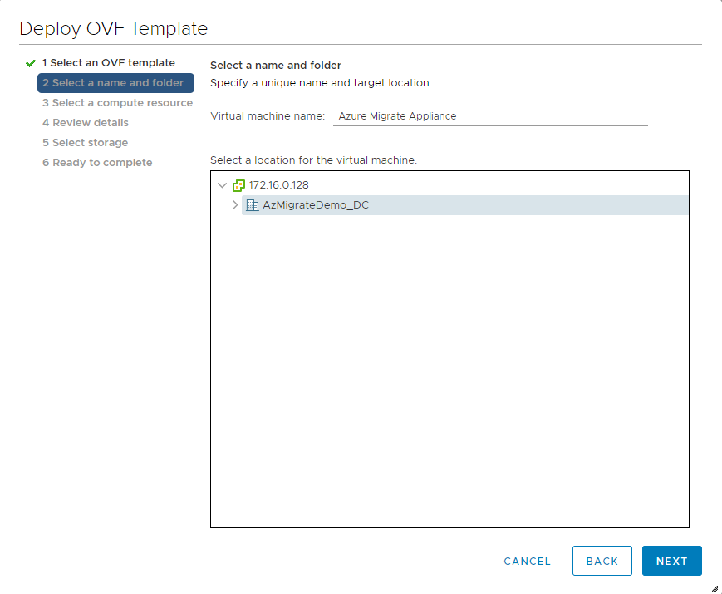
- In the Deploy OVF Template window > 3 Select a compute resource, select the target host for the virtual machine – Click Next and wait for the wizard to finish validating
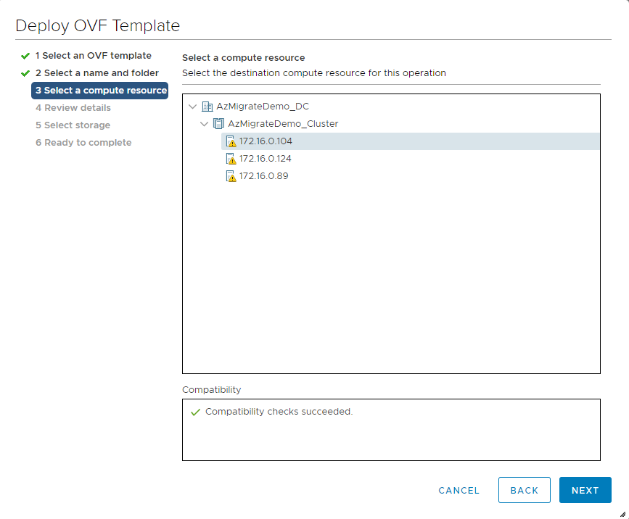
- In the Deploy OVF Template window > 4 Review details, review the details of the template – Click Next
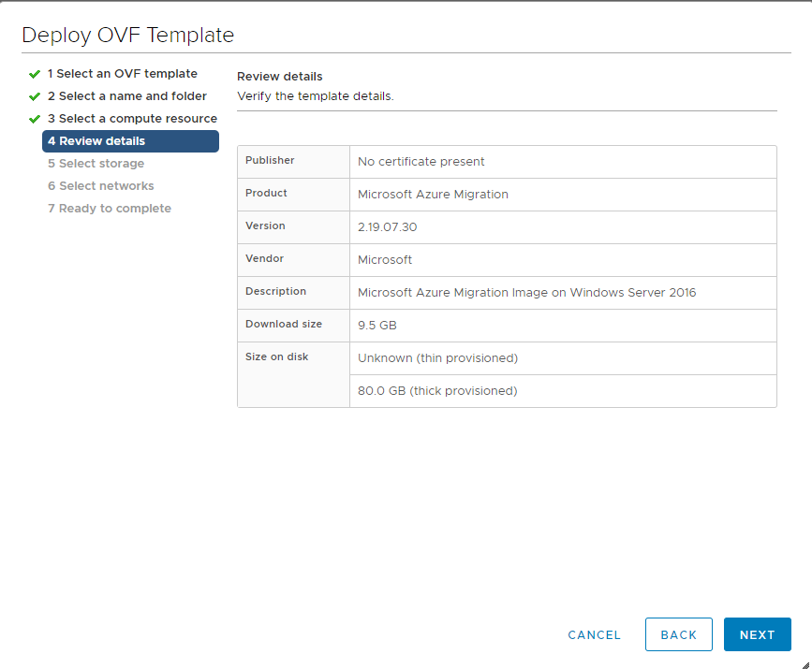
- In the Deploy OVF Template window > 5 Select storage, select the datastore and how you want to configure your disk files – Click Next
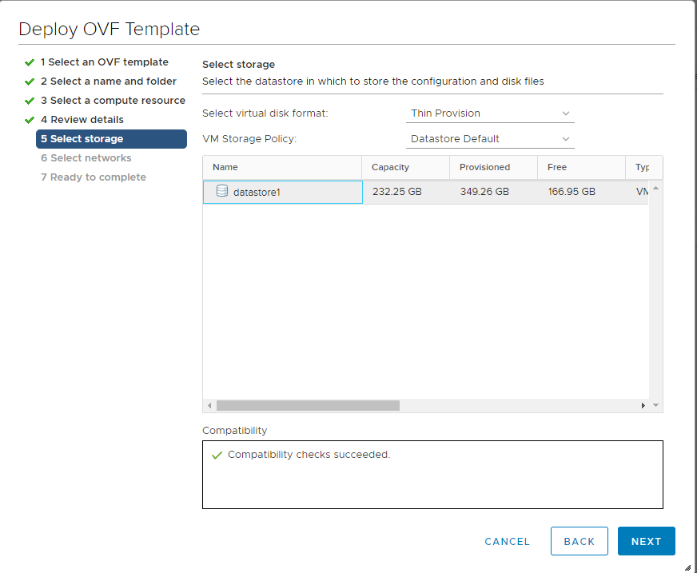
- In the Deploy OVF Template window > 6 Select networks, select your destination network – Click Next
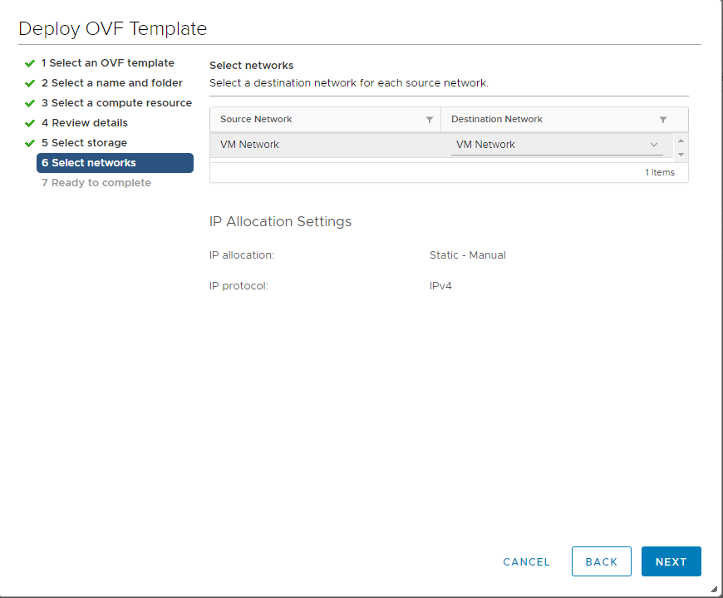
- In the Deploy OVF Template window > 7 Ready to complete, review your selections – Click Finish for your VM to start creation 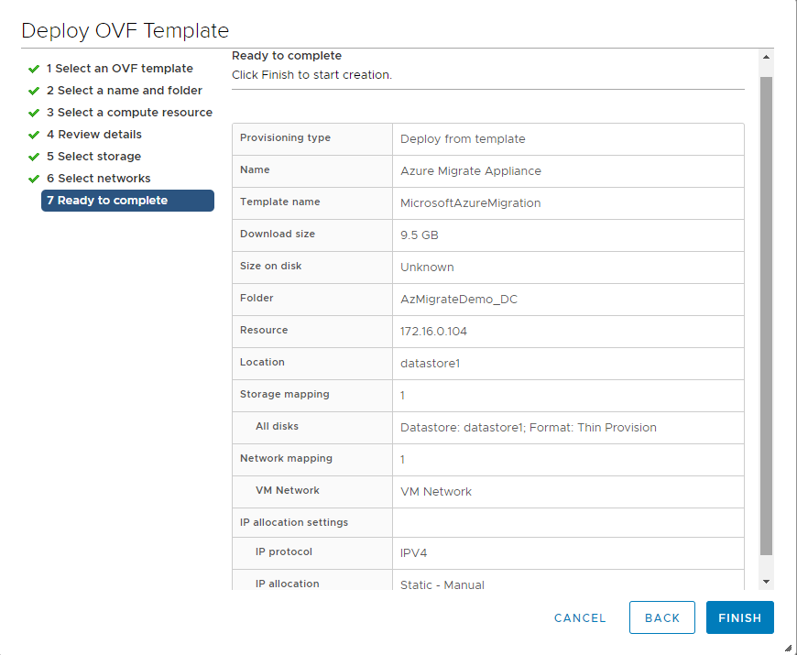
Configure Azure Migrate Appliance VM

- Once your VM is created, right-click the VM and open a console to the machine
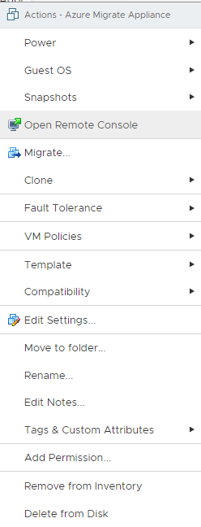
- After powering on the VM - Click Accept on the License Terms page, type in a unique password on the Customize settings page and click Finish
- You have two options here: (for the purpose of this demo, I will be using option [a])
  - Open the web application on the desktop of the VM
OR
  - Open a browser on a machine that can connect to the VM and open the URL of the appliance https://appliance name or IP Address:44368
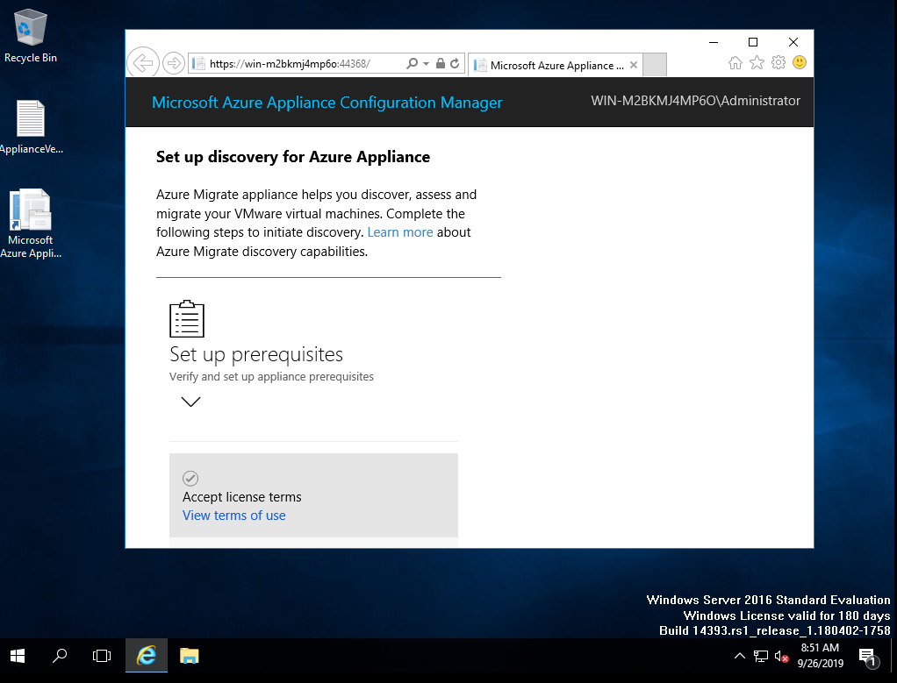

- In the web application > Set up prerequisites:
  - Accept License Terms: Accept the terms and read the agreement
  - Check connectivity to the Internet: The application will check for internet access. If you use a proxy click Set up proxy
  - Check time is in sync with the Internet time server: The time on the appliance should be in sync with the internet time for the discovery process to work properly
  - Check if the latest Azure Migrate updates are installed: This process makes sure you have the latest updates and installs them if you do not have them. You will have to restart the web app once the updates are installed
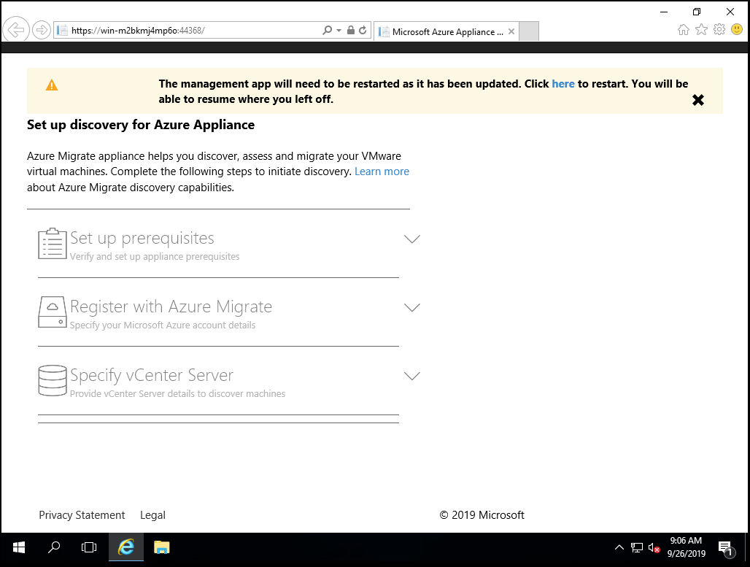
  - Install VMWare vSphere Virtual Disk Development Kit: The appliance will check that VDDK is installed and in the correct file location specified in the app. This is used to replicate machines during migration to Azure
    - Download discussed in Prerequisites section of the document
    - When finished downloading and files have been extracted to the correct location click Verify and Install
  - When all prerequisites have been met, click Continue
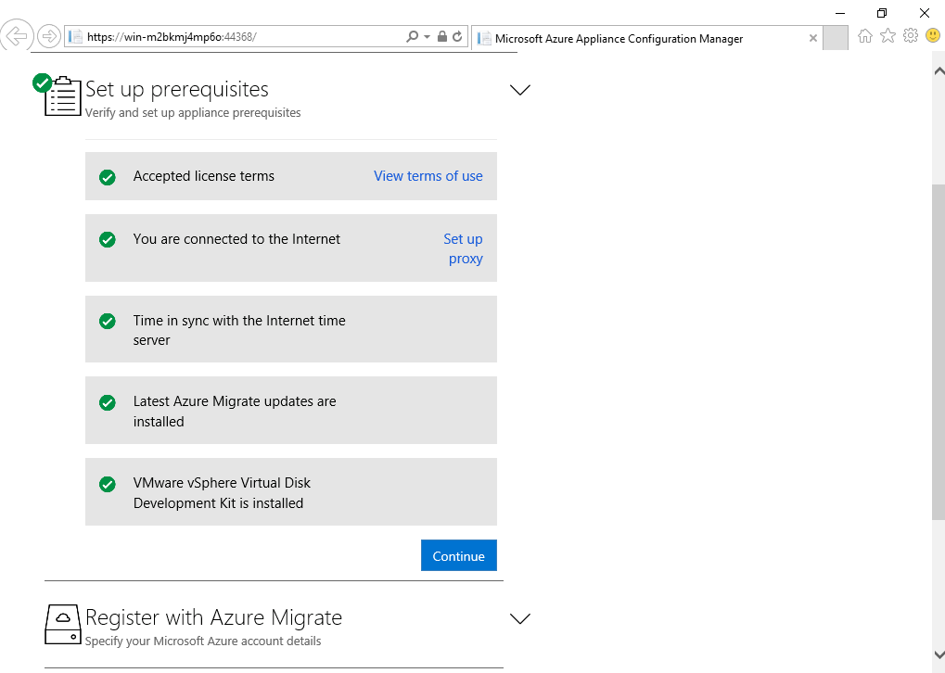
- In the web application > Register with Azure Migrate:
  - Login to Azure to Proceed: The appliance will prompt you to login to Azure by opening a new tab and prompting for credentials
  - Register with Azure Migrate: Once logged in, select the appropriate Subscription, Migrate Project, give the appliance a friendly name, click register, then click continue once it has finished.
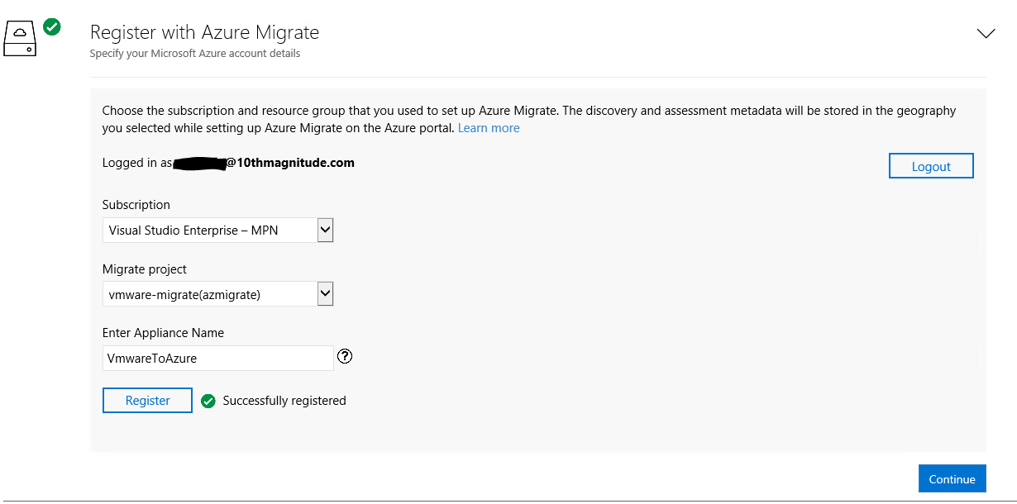
- In the web application > Specify vCenter Server:
  - Specify vCenter Server details and credentials: Supply the vCenter server name/IP address, port number (default 443), username and password used to log into the vCenter server. Click Validate connection.
  - Add Credentials (optional): Use the add credentials button to add the credentials of an account with Administrator access on the servers that will be assessed. This will allow the appliance to discover applications and dependencies on the servers. Click Save and start discovery to continue.
- After the discovery has been running for some time, CSV reports will be available on the appliance server. Servers will also start showing in the Azure Migrate project that the appliance was connected to. From here, you can start using Azure Migrate to create assessments and replicate servers for migration.

Creating Assessments in the portal

- In the Azure Portal > Azure Migrate Servers Assessment
  - Once your servers have been discovered, they will show in Azure Migrate here
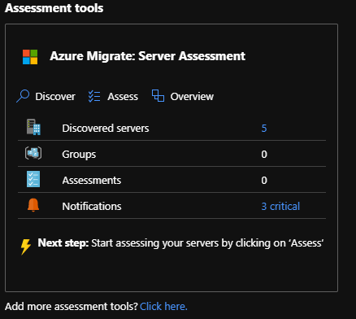
  - Discovered Servers: In this view, you can see the status and information of the discovered servers. If you wish to see dependency mapping, you can click on the Requires agent installation link to configure an OMS workspace and download the needed agents to see application dependencies, giving additional information when it comes to migration strategies
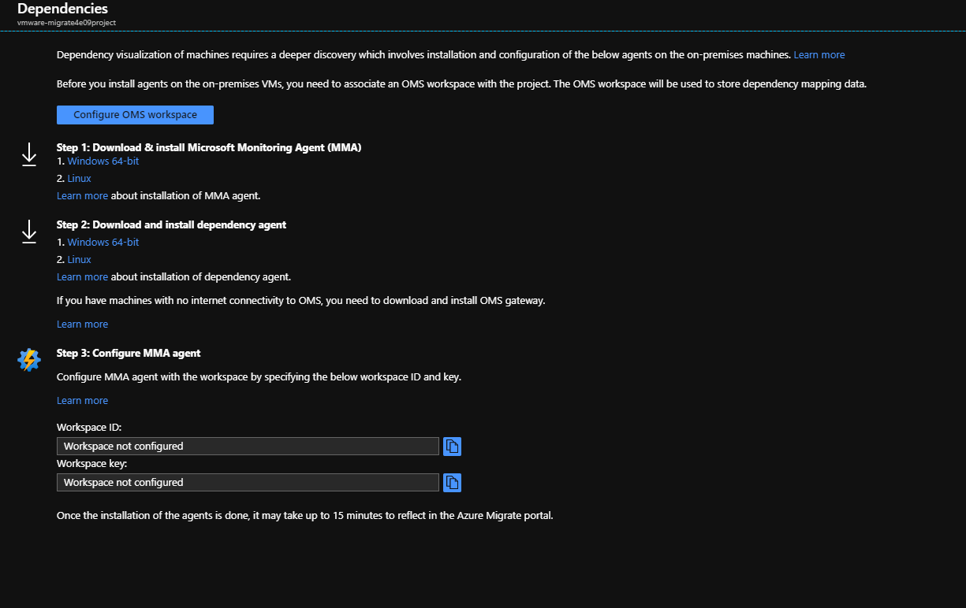

  - Click Assess: From here you will have a list of your discovered servers. Give the assessment a name, then create a new assessment group and give this a name as well. Choose the servers you wish to include in your first assessment group, then click View All next to Assessment Properties to customize the parameters of the assessment.
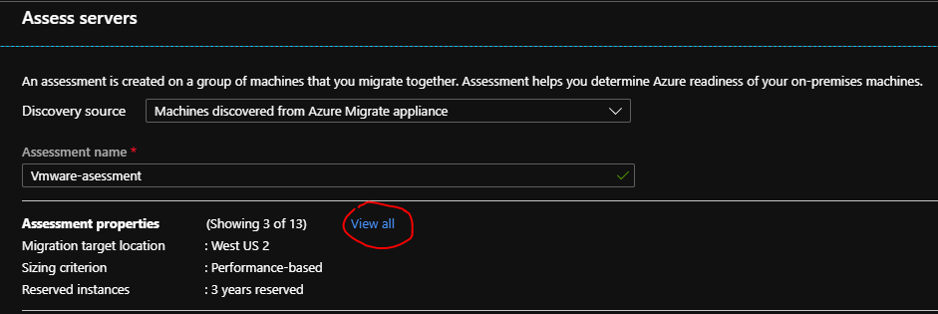
  - Assessment Properties: From here you can change the properties to match as closely as possible to your migration plan to give you an accurate assessment of estimated pricing and proper VM sizing. Once done, click save.
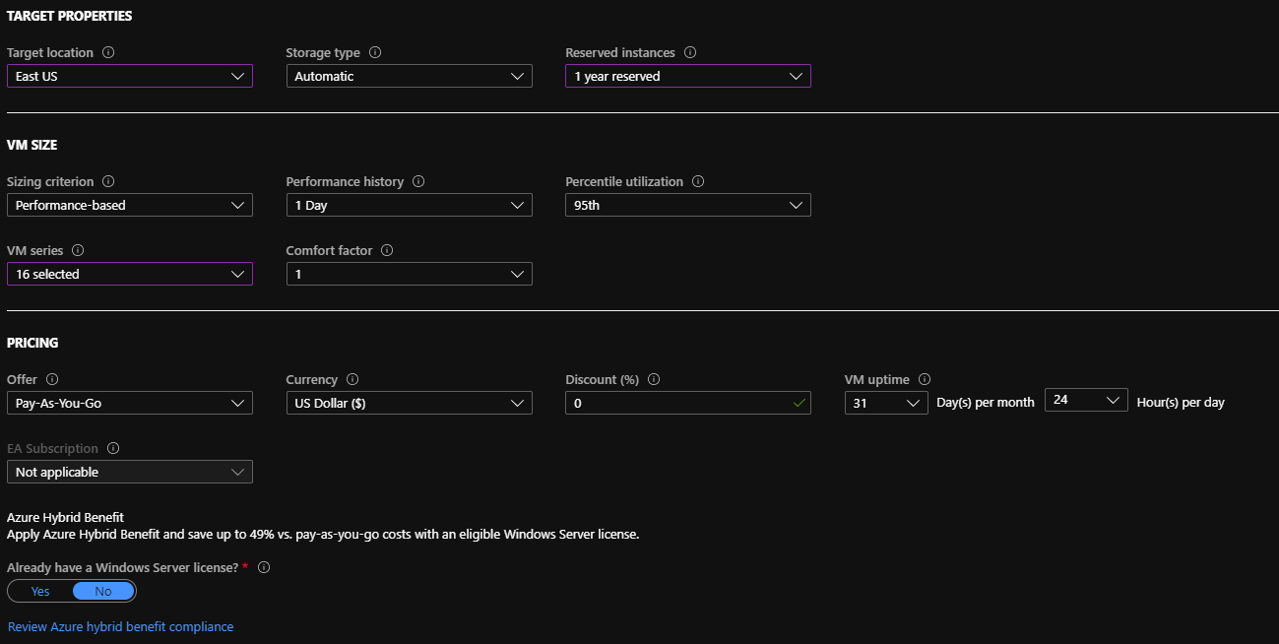

  - Back on the Assess servers, once your servers are chosen, click Create Assessment. It will take a few minutes, then the assessment will be available on the Assessment tools page, you may need to refresh for it to show.
  - Click on Assessments: Click on the name of the assessment you just created. From here you can edit properties to recalculate with different parameters, export the assessment to an Excel file, and view the details of the assessment and cost details.
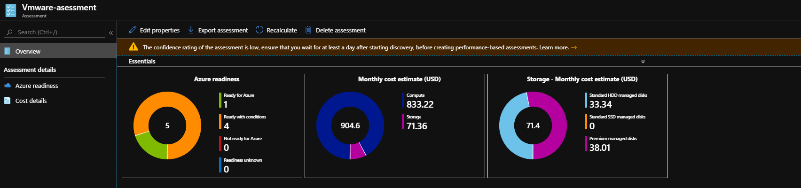

Replicating vms in the portal

- In the portal > Azure Migrate: Server Migration
  - Choose the Replicate option.
  - Choose the correct form of virtualization, and the name of the on-prem appliance. Click Next at the bottom.
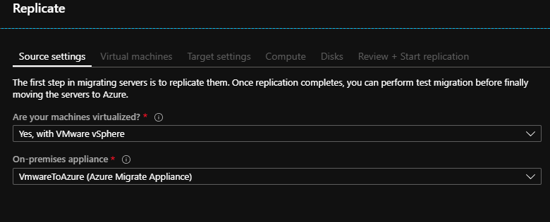
  - On the Virtual Machines page: You can select to import settings from an assessment created earlier or choose the settings later. Pick the VMs you want to replicate, then click Next: Target settings.
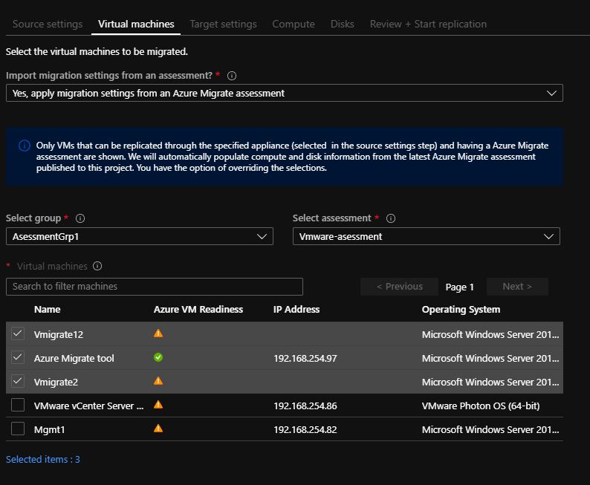
  - Target Settings: Choose the Region, subscription, Resource Group, VNET, Subnet, and Azure Hybrid Benefit settings.
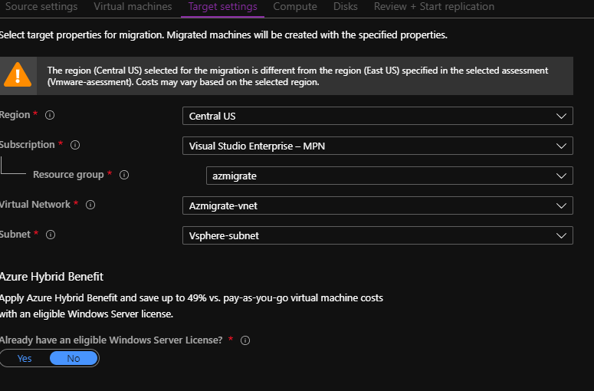
  - Compute: From here you can choose to give the VMs a new name in azure, choose the target VM size (or leave it defaulted to the assessment recommendation), OS Disk, and Availability set.
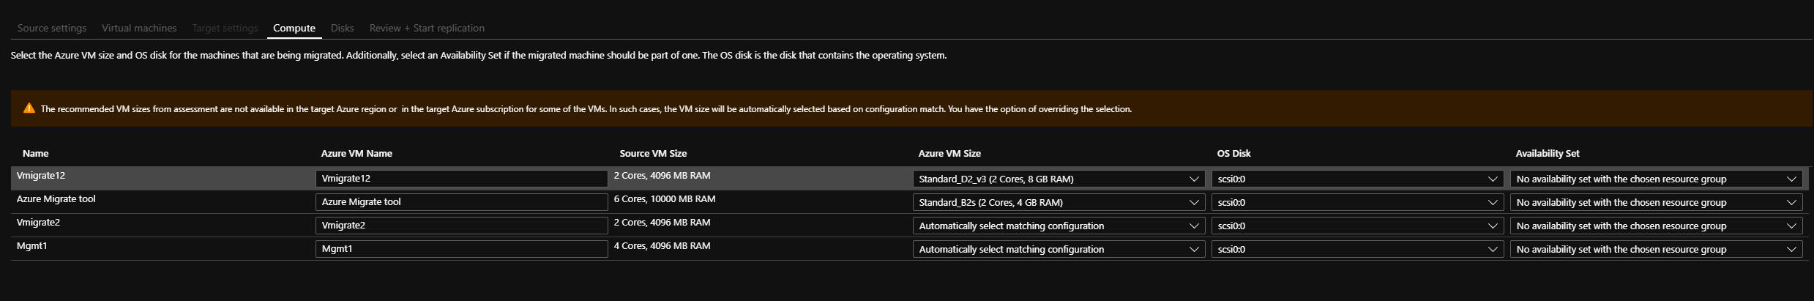
  - Disks: Choose which disks to replicate, and choose the type of the target disk (Premium, Standard SSD, Standard HDD)
  - Review + Start Replication: Review the selected settings then begin the replication on the selected VMs. This will deploy the needed artifacts (Storage accounts, Key Vaults, Namespaces) into the Resource Group you have chosen.
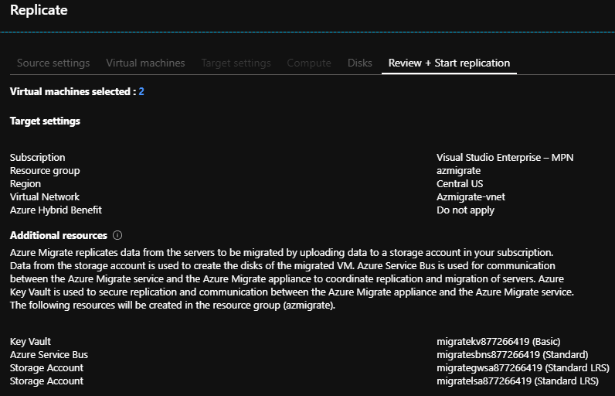
  - Check replication: Click on Replicating Servers to check on the status of replication, replication jobs, and events.
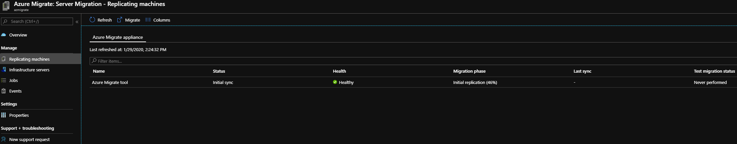

Page Break

LINUX INSTALLATION

- Copy the installer and the passphrase file to a local folder (for example, /tmp) on the server that you want to protect. In a terminal, run the following commands to change to the directory with the installer tar file and extract it:
cd /tmp
tar -xvf <filename>
- Install with the following command:
sudo ./install -r MS -v VmWare

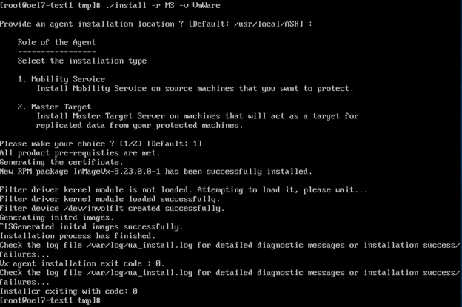

Page Break
- After installation is finished, the Mobility Service must be registered to the configuration server. Run the following command to register Mobility Service with the configuration server:
/usr/local/ASR/Vx/bin/UnifiedAgentConfigurator.sh -i <IP of Configuration Server> -P /tmp/MobSvc.passphrase

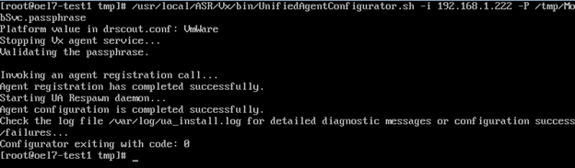

Hyper V Below this line -------------------------------

Summary

This document Is Intended to describe Azure Migrate architecture and deployment in the (Clients Name) environment to support migration to Azure. Azure Migrate is a tool used to perform discovery and assessment of on-premises infrastructure and applications. It even allows for the discovery of integrated tools developed by(ISVs).

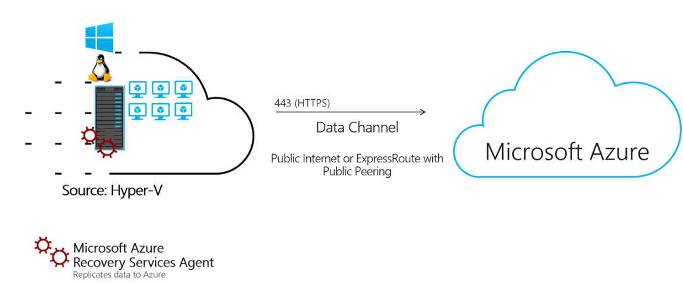

Prerequisite Activities

Prepare Azure
- You will need Contributor or Owner permissions for the Azure subscription that will be used to run Azure Migrate
- Users will need to be able to register applications in Azure Active Directory. (on by default, see https://docs.microsoft.com/en-us/azure/active-directory/develop/active-directory-how-applications-are-added#who-has-permission-to-add-applications-to-my-azure-ad-instance for more details)
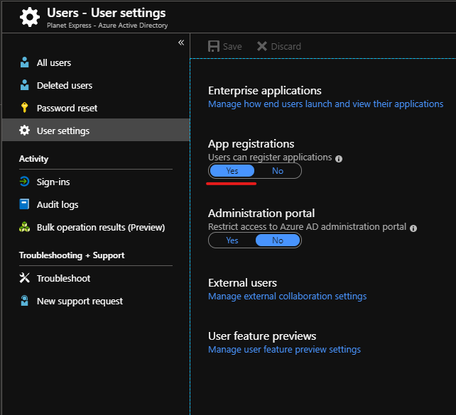

Prepare the Hyper-V Host

- The following script will validate Hyper-V hosts and configure the settings that will be needed to perform an Azure Migrate assessment on Hyper-V. The script requires PowerShell version 4.0 or higher, run as an administrator.
  - Download the script from Microsoft, here.
  - Run the script on the Hyper-V host.
  - The script will prompt you to enable/install Windows Remote Management
  - The script will prompt you to enable/install PowerShell Remoting
  - The script will prompt you to open Firewall Ports 5985 and 5986
  - The script will ask if SMB shares are used to store VHDs, if you answer yes it will Enable CredSSP on the host.
  - The script will prompt you to create a non-administrator local user that will be a member of Hyper-V Administrators, Performance Monitor Users, and Remote Management Users. (Recommended to run the Azure Migrate Appliance with this.)
- The Host’s Network Category must be set to either Private or Domain
  - To verify this, run Get-NetConnectionProfile on your host, the output will look like this.
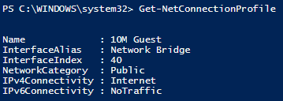
  - To change the network category type, run the following command:
Set-NetConnectionProfile -Name <”Network Name”> -NetworkCategory <”Private or DomainAuthenticated”>

Set up Azure migrate

Create an Azure Migrate project

- In the Azure Portal, search for and select Azure Migrate
- Click on “Assess and migrate servers.”
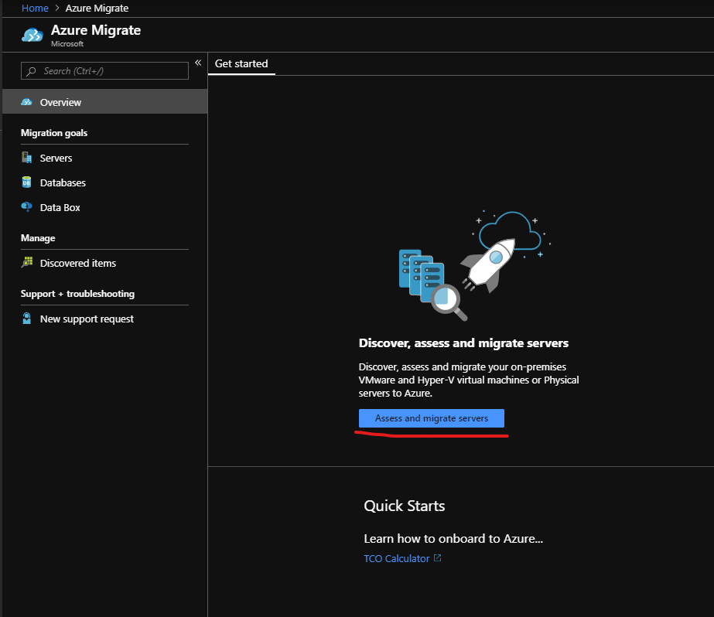
- In the Getting Started blade, click “Add Tool(s)”
- Create a new Resource group or choose an existing. Name your Migrate Project and choose a geography.
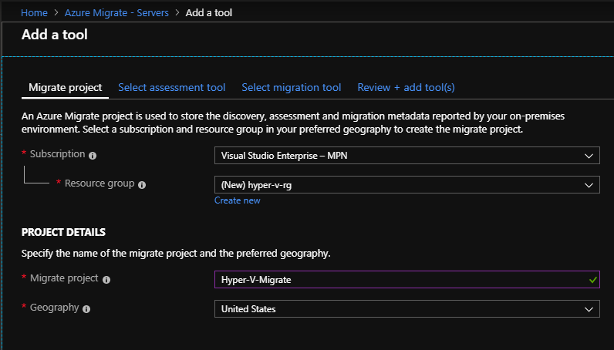
- Choose the Azure Migrate tool for assessment, then choose Azure Migrate for the migration tool. Click next.
- Click Add Tool(s)

Create the Assessment Application VM
- From the Azure Migrate – Servers page, click discover within your Azure Migrate: Server Assessment tool.
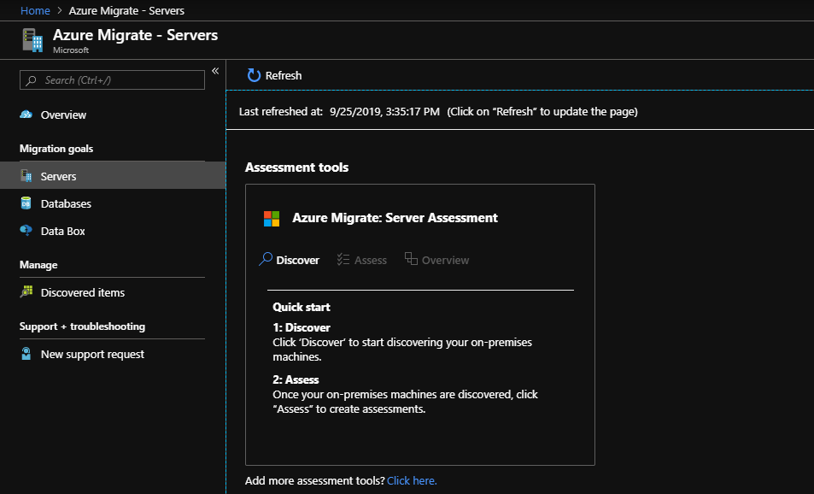
- In the drop down menu at the top of the “Discover Machines” blade, make sure that the Hyper-V option is selected.
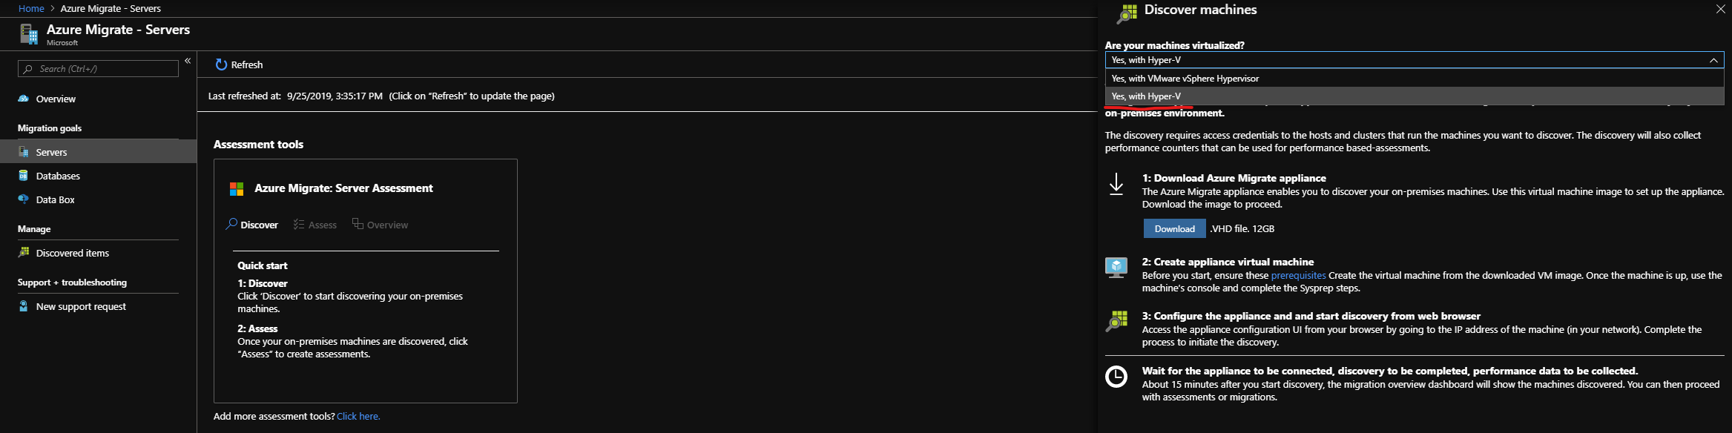
- Use the link in step 2 of the blade to download the .VHD file that will be used to create the virtual Appliance.
- Extract the .zip file to a directory of your choice, this will be used to create the assessment appliance.
- In Hyper-V manager, select the “Import Virtual Machine” option.
  - For the locate folder step, choose the Virtual Machines folder that you unzipped in step 4.
  - Select the AzureMigrateAppliance<version number> VM
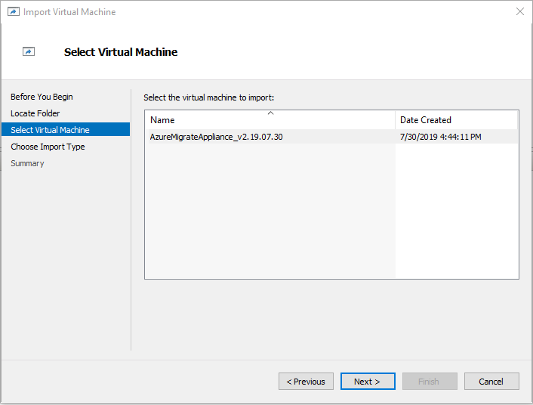
  - Under “Choose Import Type,” select Copy the Virtual Machine (create a new unique ID)
  - The next step will allow you to change the location of the virtual machine files if desired
  - Choose which folder to store the imported VHD files
  - Specify the connection that the imported machine will use
  - Click finish to create the VM appliance.
- Start the Azure Migrate Appliance virtual machine

Configure the Azure Migrate Appliance

- Once you connect to the new virtual machine, agree to the license terms and set a password for the built-in admin account, then sign in.
- After signing in, it should automatically open the Microsoft Azure Appliance Configuration Manager
- Accept the license terms, and allow the appliance to check connectivity to the internet.
- The appliance will then prompt you to sign in with the same admin credentials used to sign into the virtual machine
- Allow updates to install, and click restart in the banner that comes up at the top of the page to restart the application after updating.
- You will have to accept the license terms again, then click continue after goes through the checks again.
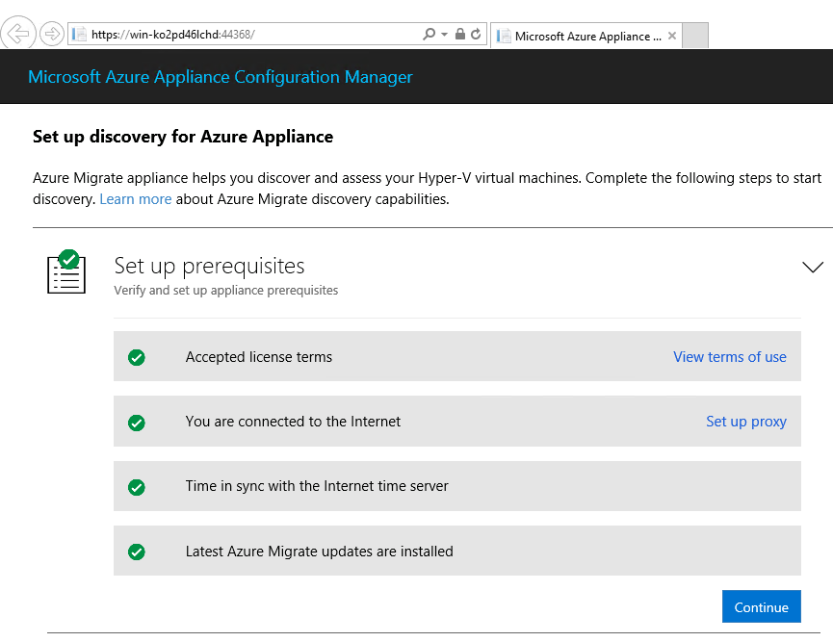
- In the next step you will have to login to Azure, it will open a separate tab to do so.
- After signing in, select the subscription the project was created in.
- Select the migrate project created earlier
- Give the appliance a name for identification later, then click register and continue
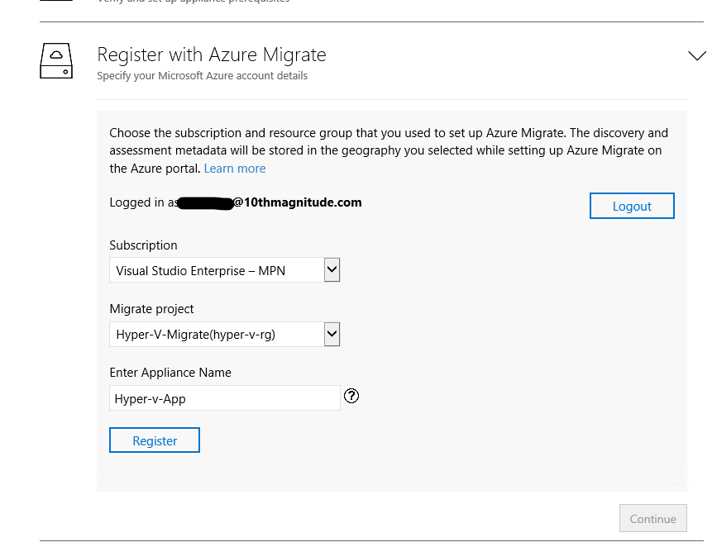
- Provide the credentials for an account that has administrator permissions on the Hyper-V host. Use the account created by the script earlier in the process if you granted it full admin rights. Click save details.
- Add the IP addresses or FQDNs of the hosts/clusters you wish to run the discovery on. Once the hosts are validated and the status shows a green check, you can click “Save and start discovery.”
- The process will take a few minutes to complete, more depending on the number of servers discovered.
- Open the azure portal, and navigate to the Azure Migrate blade. Click Servers under Migration goals on the left side, and use the refresh option. The discovered servers should be listed.
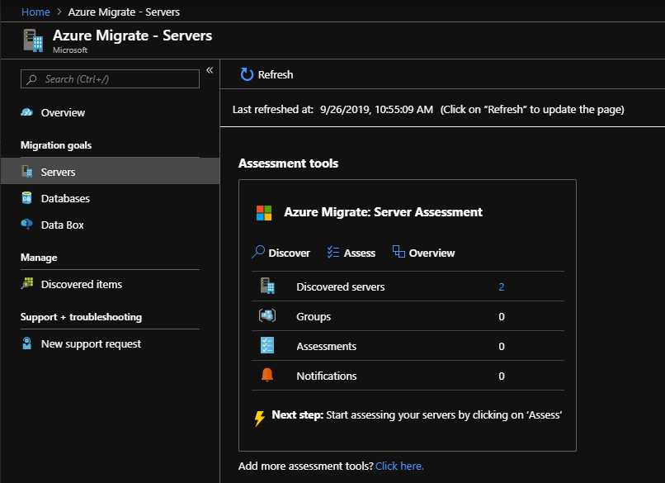
Configure the Azure Migrate Appliance

- Under the Azure Migrate: Server Assessment, click “Assess”
- Create an assessment name
- Create a new server group for assessment and give it a name as well
- Choose the appliance name that was created earlier from the drop down
- Select the discovered servers from the list to add to the assessment group, then create assessment at the bottom of the page.
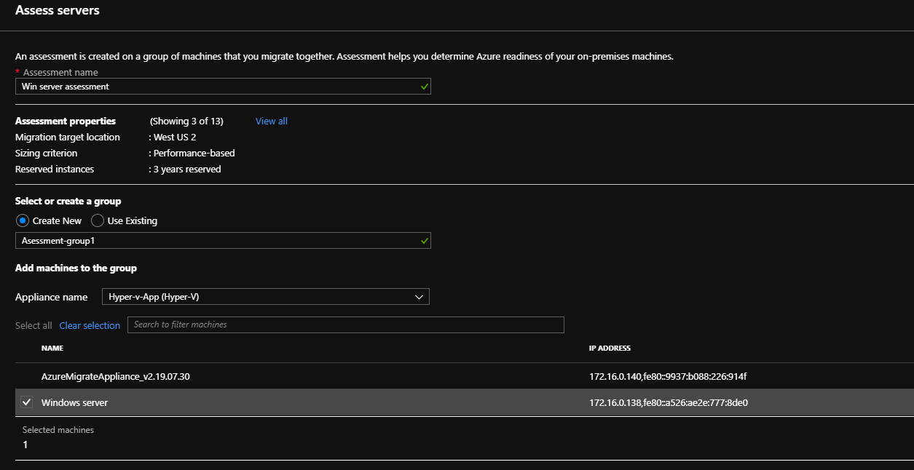
- After some time, you should be able to refresh the page with the assessment tools, and your assessment will be available.
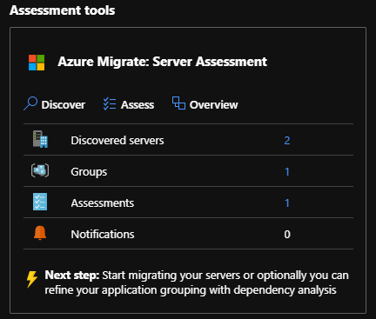
- Click the number next to “Assessments,” then choose the name of the assessment created earlier. This will take you to the assessment overview page.
- From here you will be able to export the assessment, recalculate it, delete the assessment, view the Azure readiness of the VMs, and estimated costs.
- It is best to wait a day after starting discovery for the assessment tool to better gauge the performance of the VMs discovered, as to provide more accurate information on the estimated costs and size of Azure VMs needed.
